|  |  |  |  |  |
| --- | --- | --- | --- | --- |
| Test | Input | Expected output | Output | Pass/Fail |
| 1.Register/login | James  ABcdefghij.1 | Login succesful | As expected | Pass |
| 2.Secured route cant be accessed while not logged in | Logout, try to acceess the “table” page which is secured | Should be redirected to the login page | As expected | Pass |
| 3.Images display | Check for 4 images on website | Should see any image on all pages other than login and register | As expected | Pass |
| 4.Table displays | Check for table on table page | Should see a table for players, position, and yards | As expected | Pass |
| 5.User register and login forms | Make sure register and login works, after logged in try to open table page in edge while logged out | While logged in on chrome should be able to access table page, opposite for edge | As expected | Pass |
| 6.Password complexity check | A. ABcdefghijk.1  B.abcdefghijklm  C.AbcdefghijkLm  D.1234567891011  E............ | For the first password, it should be accepted, all other should be denied | As expected | Pass |

1.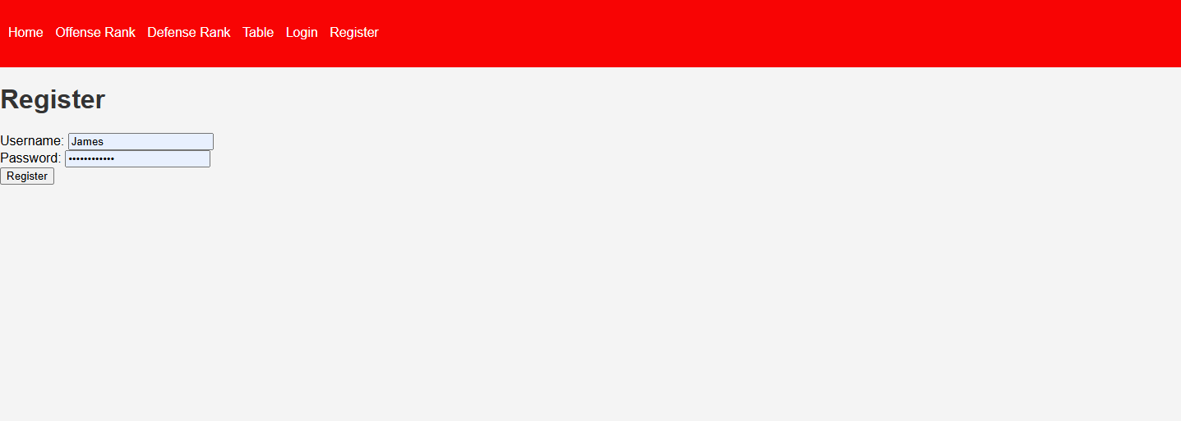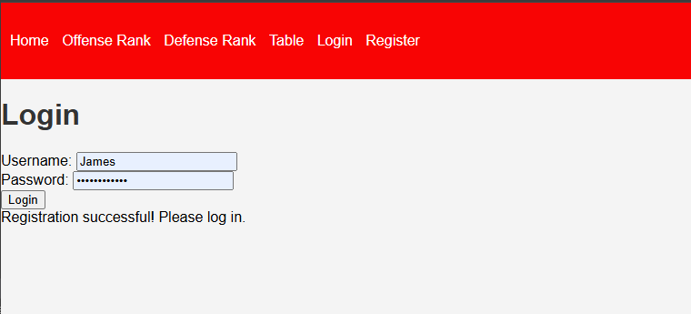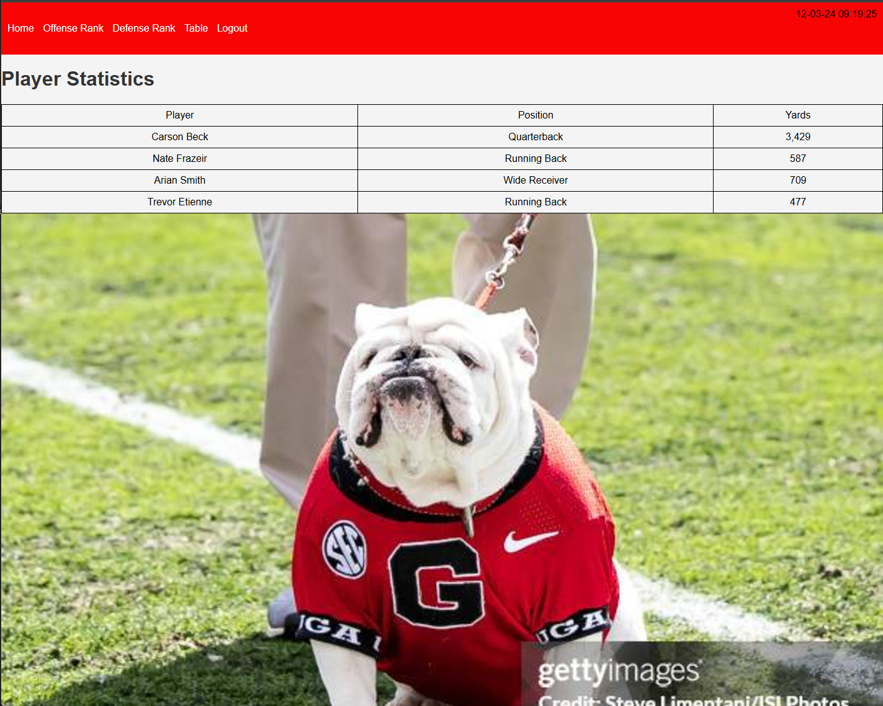

2.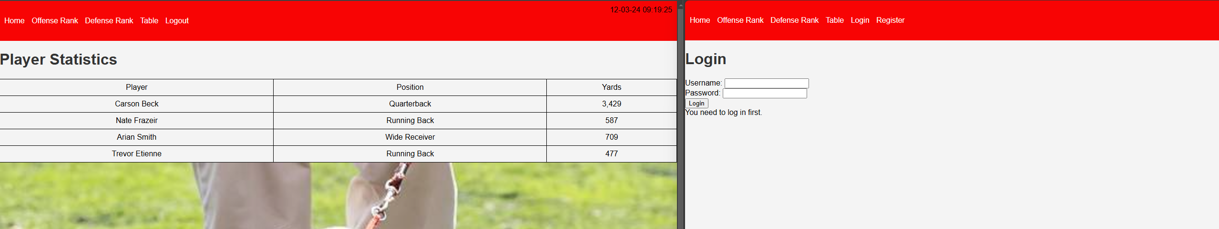

3.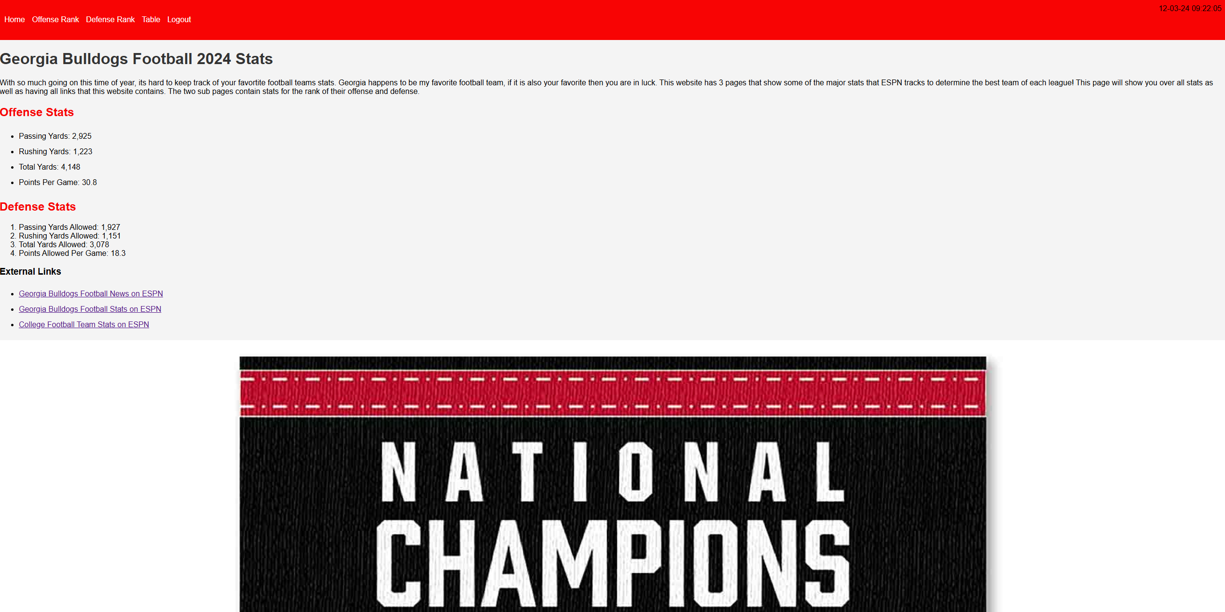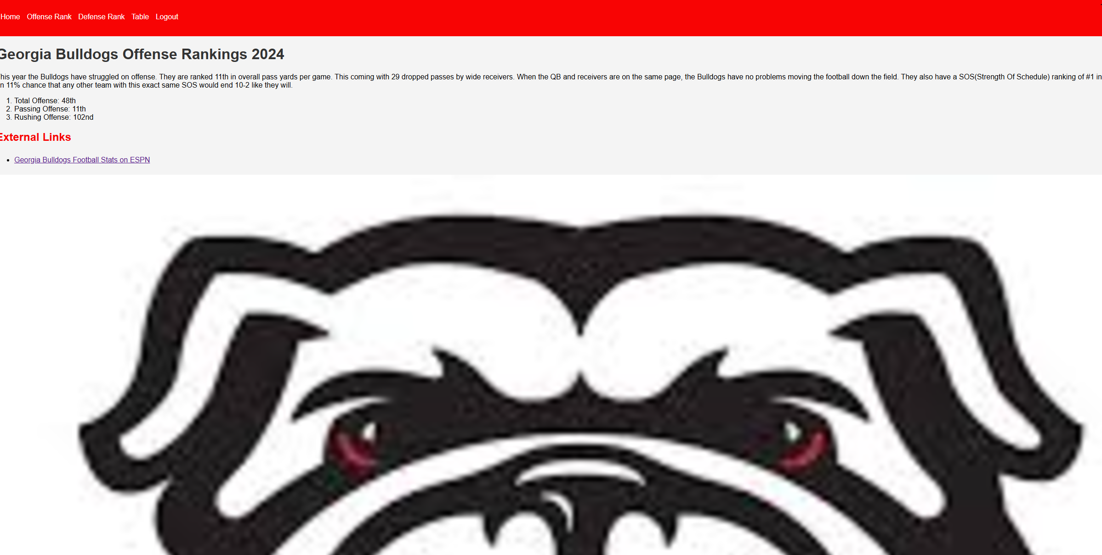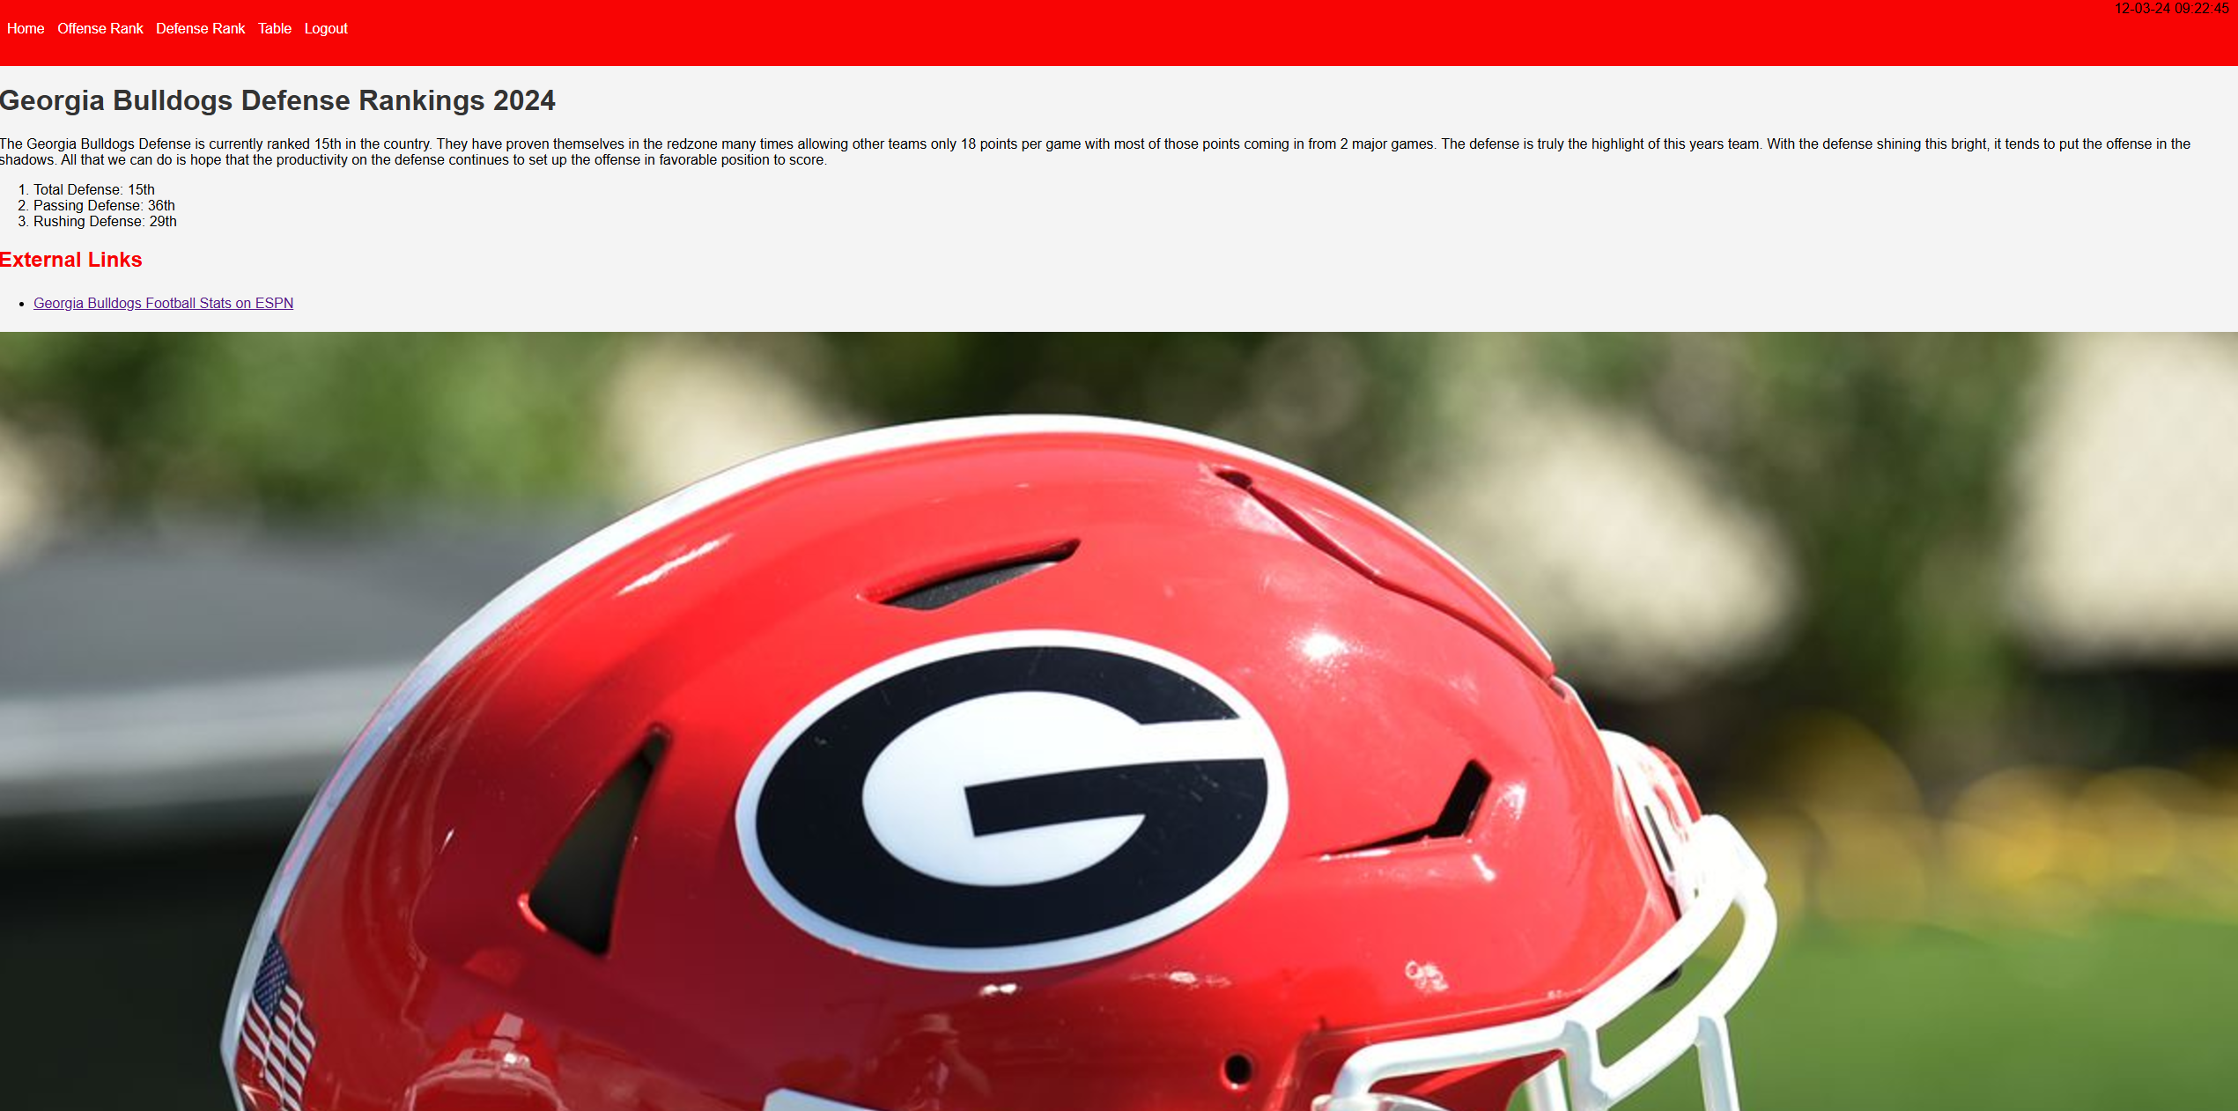I have learned from this test that not all pictures can fit the screen without being pixelated

4.

5.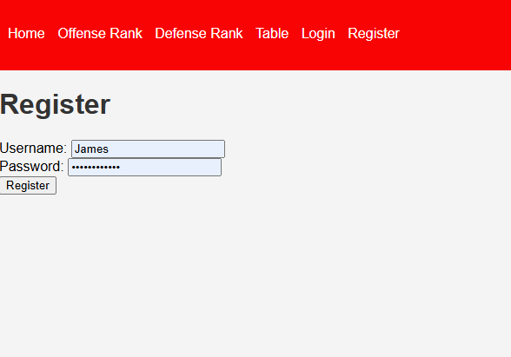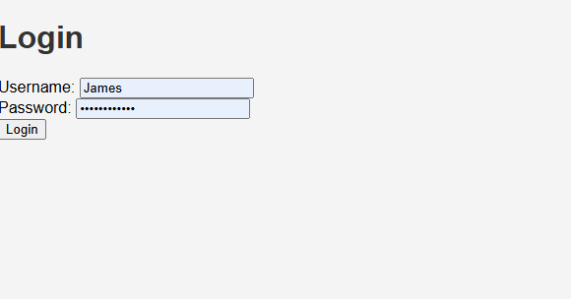

6.A.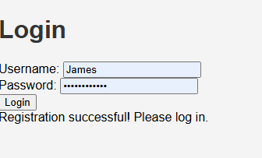

B.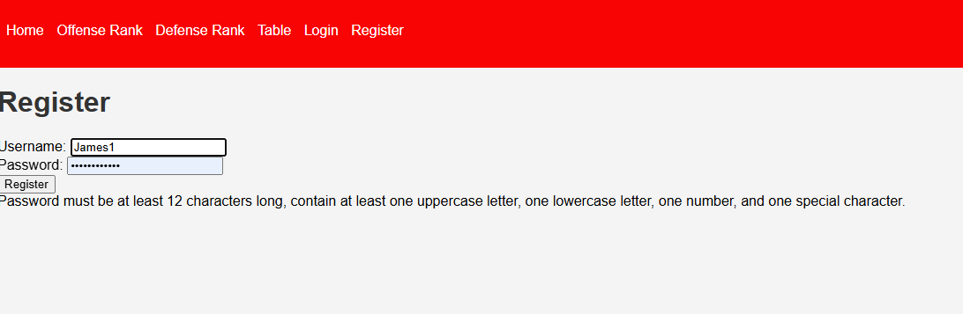

C.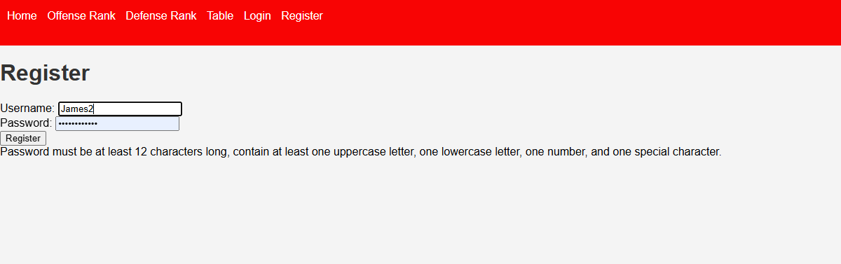

D.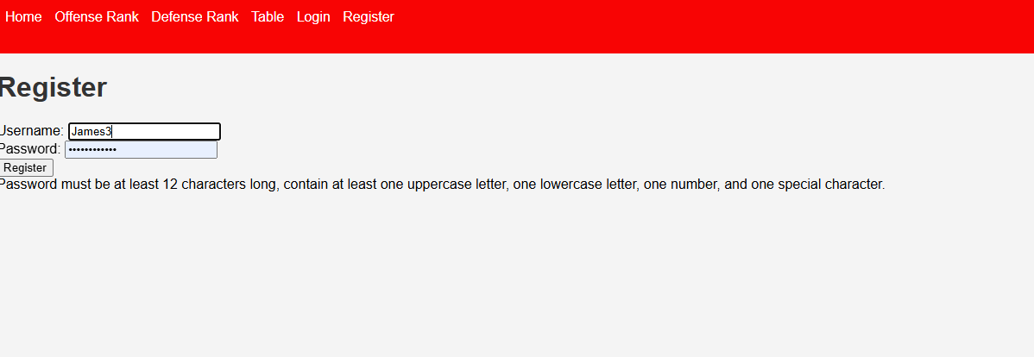

E.